1. **what is exception?**

**Ans:** An event, which occurs during the execution of a program, that disrupts the normal flow of the program's instructions.

1. **what is exception handling?**

**Ans**: Exception handling is the process of responding to unwanted or unexpected events when a computer program runs.

1. **Exception Hierarchy?**

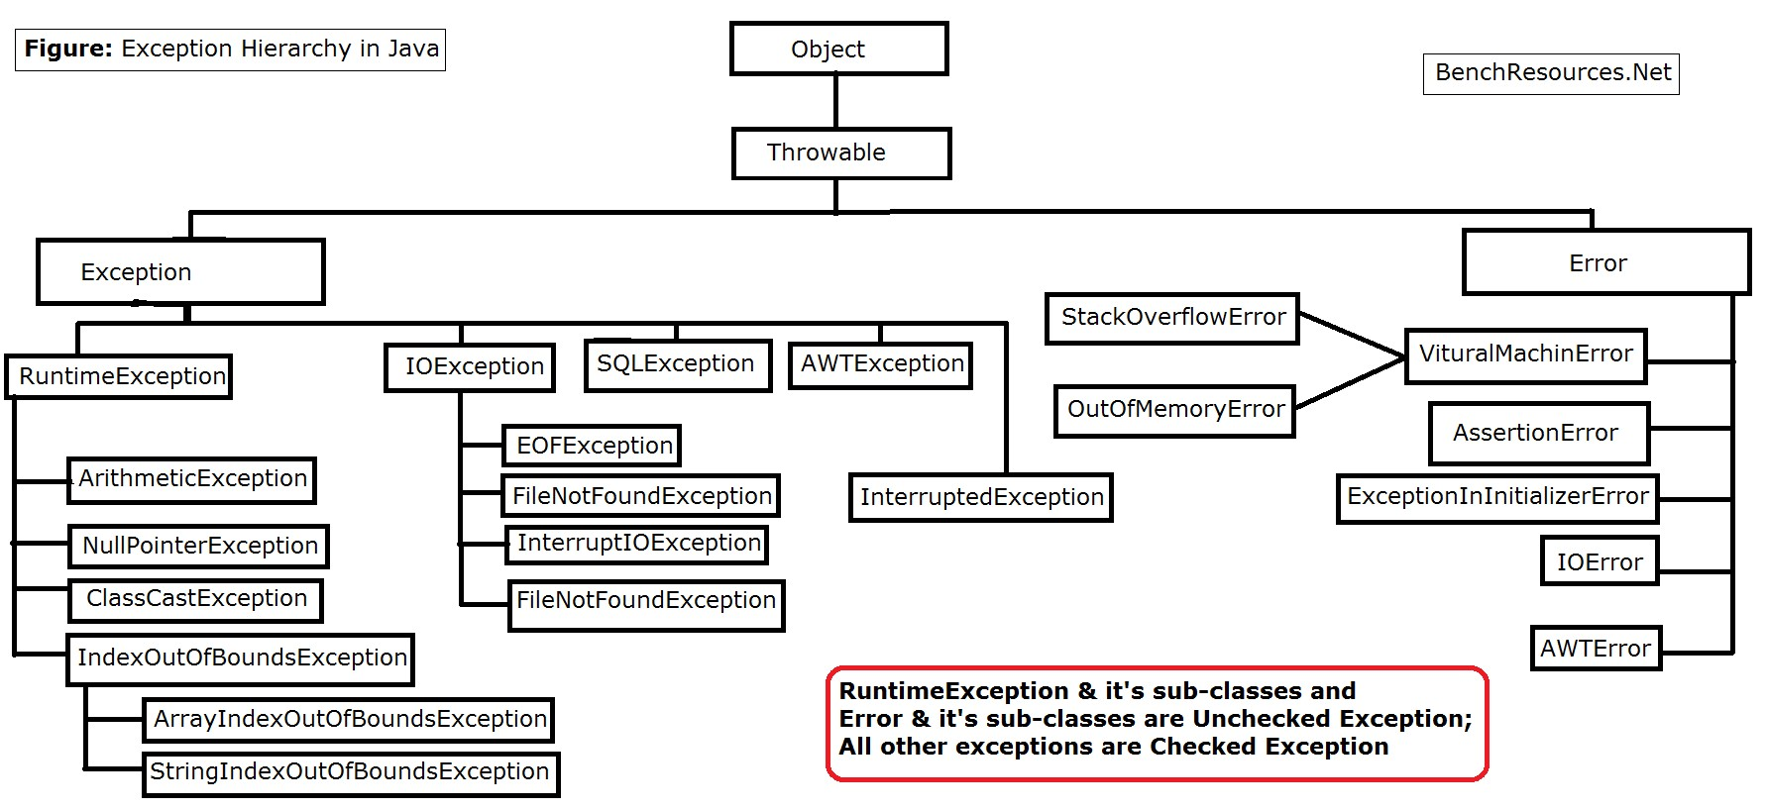

1. **What is checked exceptions and how will you handle it?**

**Ans**: A checked exception is caught at compile time whereas a runtime or unchecked exception is, as it states, at runtime.

A checked exception must be handled either by re-throwing or with a try catch block,

1. **what is unchecked exceptions and how will you handle it**

**Ans:** An unchecked exception (also known as an runtime exception) in Java is something that has gone wrong with the program and is unrecoverable

1. **types of handling checked exceptions?**

**Ans: Following are the types: Checked exception**

throw keyword. It is clearly displayed in the output that the program throws exceptions during the compilation process. ...

1. try-catch block. ...
2. SQLException. ...
3. IOException. ...
4. ClassNotFoundException. ...
5. InvocationTargetException. ...
6. NullPointerException. ...
7. ArrayIndexOutofBound.

1. **Why do we need the finally block?**

**Ans:** finally is useful for more than just exception handling — it allows the programmer to avoid having cleanup code accidentally bypassed by a return , continue , or break . Putting cleanup code in a finally block is always a good practice, even when no exceptions are anticipated.

1. **Is multiple catch blocks allowed?**

**Ans:** Yes you can have multiple catch blocks with try statement

1. **What is the output of below program try{ int num=14/0; }catch(Exception ex)**

**{**

**Sop("base exception");**

**}catch(ArthmeticException e){sop("child exception")} Ans:** child exception

1. **what is try with resources?**

**Ans:** The try -with-resources statement is a try statement that declares one or more resources. A resource is an object that must be closed after the program is finished with it. The try -with-resources statement ensures that each resource is closed at the end of the statement. Any object that implements java.

1. **difference between the closeable and autocloseable?**

**Ans:** Closeable extends AutoCloseable and Closeable is mainly directed to IO streams. Closeable extends IOException whereas AutoCloseable extends Exception. Closeable interface is idempotent (calling close() method more than once does not have any side effects) whereas AutoCloseable does not provide this feature.

1. **which method is present in closeable? Ans:**The close() method

1. **name few classes implementing the closeable?** • **Ans:** AbstractSelectableChannel.

* AbstractSelector.
* BufferedReader.
* BufferedWriter.
* BufferedInputStream.
* BufferedOutputStream.
* CheckedInputStream.
* CheckedOutputStream.

**14. Types of filehandling classes?**

**Ans:**

* AudioInputStream.
* ByteArrayInputStream.
* FileInputStream.
* FilterInputStream.
* StringBufferInputStream.
* ObjectInputStream.

1. **What is the return type of read method() in FileReader class?**

**Ans:** The read() method returns a single character in the form of an integer value that contains the character's char value.

It returns -1 when all of the data has been read and that FileReader may be closed.

1. **Name the exceptions come across while working with filehandling?**

**Ans**: FileNotFoundException

1. **FileReader constructor throws which exception? Ans**: FileNotFoundException.

1. **read() method and close() method throws which exception? Ans:** read() method and close() method throws IOException.

1. **Name few unchecked exceptions and checked exceptions? Ans:** Some unchecked exceptions are
   * ArithmeticException,
   * ClassCastException,
   * NullPointerException,
   * IllegalArgumentException, etc